TASK 3 – Data Visualization

Objective :
To analyze monthly mobile phone sales data and create visualizations that understands sales trends and business performance.

Dataset :
Month | Sales
January | 98,000
February | 60,000
March | 210,000
April | 140,000
May | 160,000
June | 155,000
July | 150,000
August | 163,000
September | 308,000
October | 206,000
November | 350,000
December | 330,000

Tools used :

Tableau

Microsoft word

Visualizations :

LINE GRAPH :

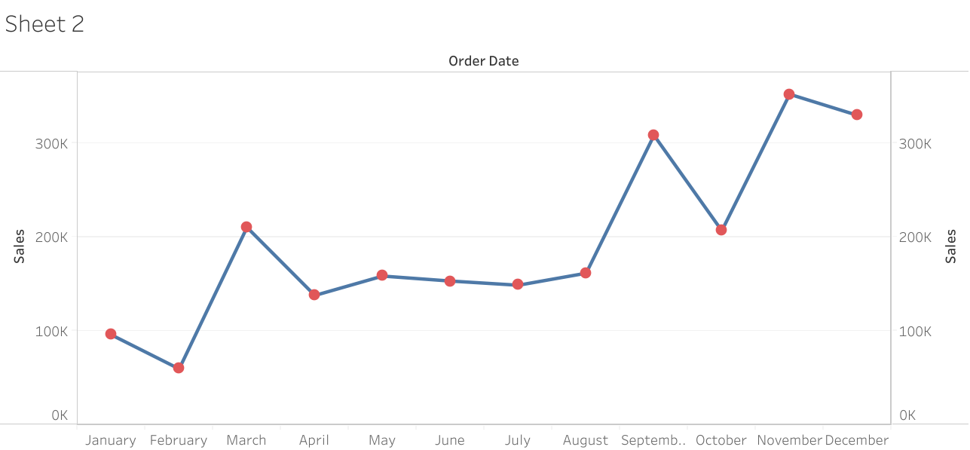

PROFIT and SALES :

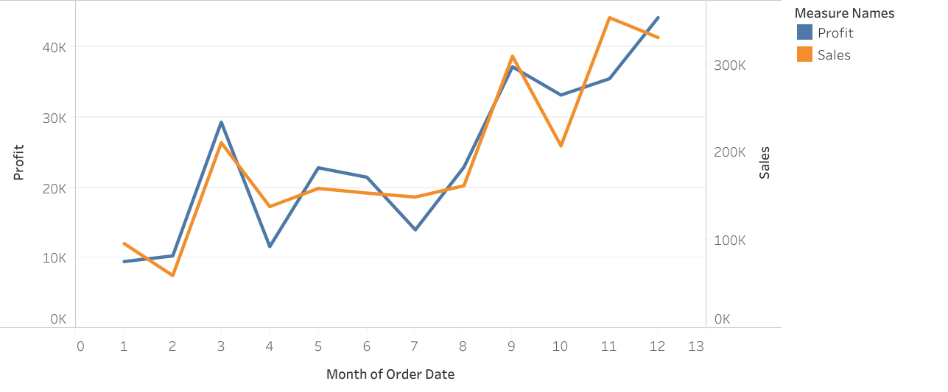

BAR GRAPH :

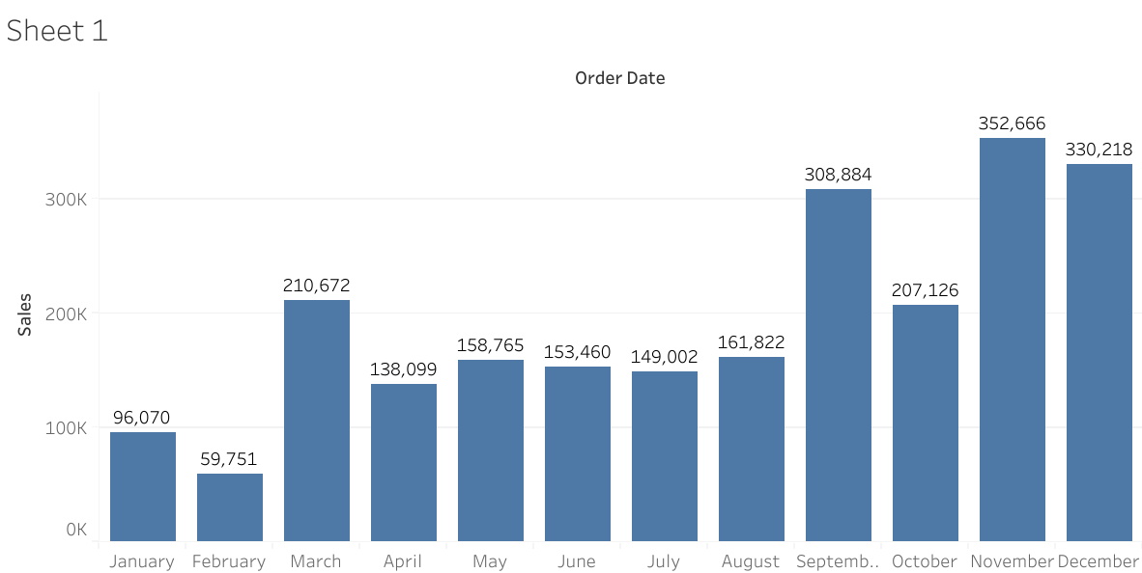

PIE CHART :

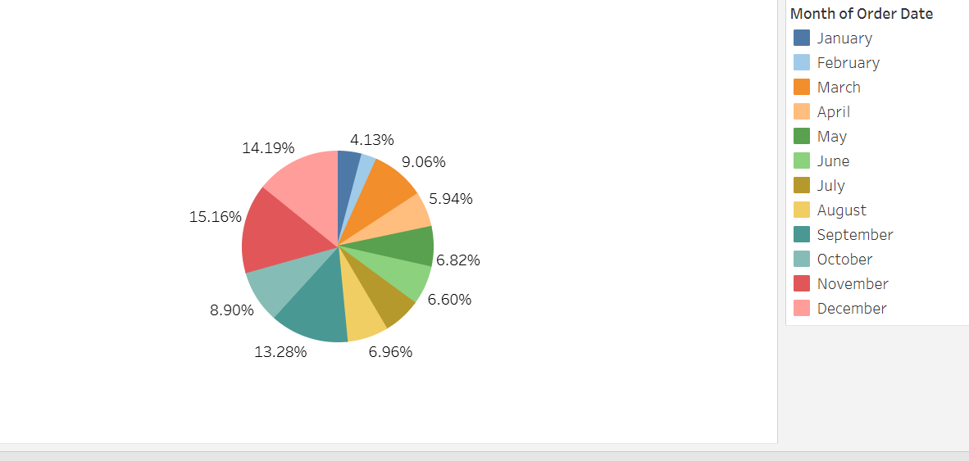

Analysis and Insights

- Sales were lowest in February.

- Sales increased significantly in March.
- Sales remained stable from April to August.

- Sales grew rapidly from September onwards.

- November recorded the highest sales.

- Overall sales showed an increasing trend.

Data Story :

The sales data shows how the company's performance changed throughout the year. Sales started at 98,000 in January and dropped to 60,000 in February, indicating a slow period. In March, sales increased sharply to 210,000, showing a strong recovery.
From April to August, sales remained relatively stable, ranging between 140,000 and 163,000. This suggests consistent customer demand during the middle of the year.
A significant increase occurred in September, when sales rose to 308,000. Although sales dipped slightly in October, they reached the highest value of 350,000 in November and remained high at 330,000 in December.
The overall trend indicates that the company experienced strong growth during the second half of the year. The high sales in the final months may be due to seasonal demand, festive offers, or successful marketing campaigns. These insights can help the company plan future inventory, promotions, and business strategies more effectively.

Conclusion :
This project successfully transformed raw sales data into meaningful visualizations using charts and graphs. The analysis revealed important sales trends, including low sales in February, steady growth during the middle of the year, and peak sales in November and December. Data visualization made it easier to understand business performance and identify patterns. These insights can help organizations make better decisions regarding inventory management, marketing strategies, and future business planning.

